**Data Exploration**

Data Set Overview

The table below lists each of the files available for analysis with a short description of what is found in each one.

|  |  |  |
| --- | --- | --- |
| **File Name** | **Description** | **Fields** |
| **ad-clicks.csv** | A detailed description of players’ clicks on advertisements | **timestamp**: when the click occurred.  **txId**: a unique id assigned to the click  **userSessionid**: the session id of the session in which the user made the click  **teamid**: the current team id of the user who made the click  **userid**: the id of the user who made the click  **adId**: the id of the ad clicked on  **adCategory**: the category of the ad clicked on |
| **buy-clicks.csv** | A detailed record of players’ in-app purchases | **timestamp**: when the purchase was made.  **txId**: a unique id assigned to the purchase  **userSessionId**: the session id of the session in which the user made the purchase  **team**: the current team id of the user who made the purchase  **userId**: the id of the user who made the purchase  **buyId**: the id of the item purchased  **price**: the price of the item purchased |
| **users.csv** | This file contains information about the game’s players. | **timestamp**: when user first played the game.  **userId**: a unique id assigned to the user.  **nick**: the nickname chosen by the user.  **twitter**: the twitter handle of the user.  **dob**: the date of birth of the user.  **country**: the two-letter country code where the user lives. |
| **team.csv** | A detailed record of terminated teams | **teamId**: the id of the terminated team  **name**: the name of the terminated team  **teamCreationTime**: when the team was created  **teamEndTime**: when the last member left the team  **strength**: a measure of team strength at point of termination  **currentLevel**: the level of the team at point of termination |
| **team-assignments.csv** | A record of players’ team-joining events | **timestamp**: when the user joined the team.  **team**: the id of the team that the user joined  **userId**: the id of the user  **assignmentId**: a unique id assigned to this joining event |
| **level-events.csv** | A detailed record of every time a team engages with levels | **timestamp**: when the engagement occurred.  **eventId**: a unique id assigned to the engagement  **teamId**: the id of the team  **teamLevel**: the level engaged by the team  **eventType**: the type of event, either ‘start’ or ‘end’ |
| **user-session.csv** | A detailed record of every time a user starts/ends a playing session | **timestamp**: when the event occurred.  **userSessionId**: a unique id assigned to the session.  **userId**: the current user's ID.  **teamId**: the id of the user's current team.  **assignmentId**: the team assignment id assigned when the user joined the current team  **sessionType**: whether the event type is ‘start’ or ‘end’  **teamLevel**: the level of the team during this session.  **platformType**: the platform type the user used during the session. |
| **game-clicks.csv** | A detailed description of all clicks performed by the user during playing | **timestamp**: when the click occurred.  **clickId**: a unique id assigned to the click.  **userId**: the id of the user performing the click.  **userSessionId**: the id of the session the user was in when the click occurred.  **isHit**: Boolean value denotes if the click hit the flamingo (value is 1) or missed the flamingo (value is 0)  **teamId**: the id of the user’s current team  **teamLevel**: the current level of the user’s current team |

Aggregation

|  |  |
| --- | --- |
| Amount spent buying items | 21407.0 |
| Number of unique items available to be purchased | 6 |

A histogram showing how many times each item is purchased:

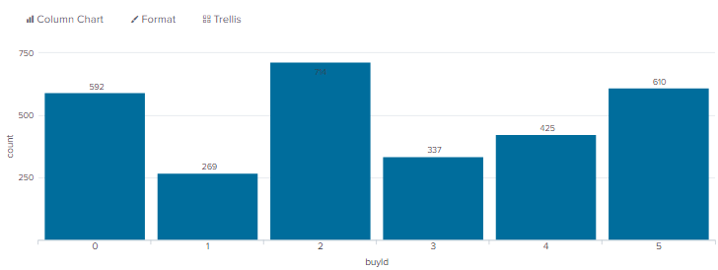

A histogram showing how much money was made from each item:

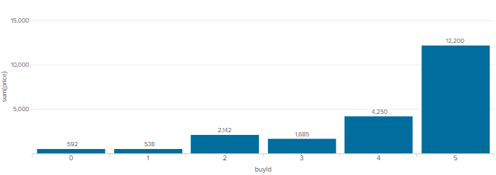

Filtering

A histogram showing total amount of money spent by the top ten users (ranked by how much money they spent).

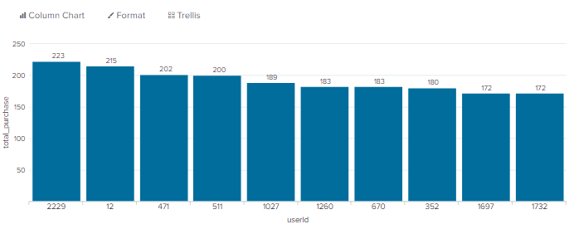

The following table shows the user id, platform, and hit-ratio percentage for the top three buying users:

|  |  |  |  |
| --- | --- | --- | --- |
| **Rank** | **User Id** | **Platform** | **Hit-Ratio (%)** |
| 1 | 2229 | iPhone | 11.60 |
| 2 | 12 | iPhone | 13.07 |
| 3 | 471 | iPhone | 14.50 |